WEATHER MONITORING SYSTEM USING RASPBERRYPI
Name: Manideep Sai
VIT-AP UNIVERSITY, Amaravathi, Andhra Pradesh. 522237

ABSTRACT
In recent years, the need for real-time and accurate weather monitoring has increased a lot because it plays an important role in areas such as agriculture, disaster management, and urban planning. Weather monitoring systems use different sensors to collect environmental data like temperature, humidity, light intensity, and rainfall. This information helps us understand weather conditions better and also supports predictions that can help people make better decisions.With the growth of Internet of Things (IoT) technology and machine learning, weather monitoring systems have become more advanced and easier to implement. These technologies allow systems to collect data automatically and analyze it to provide useful insights.In this project, a Raspberry Pi-based weather monitoring system is developed using multiple sensors. The system includes an LDR sensor to measure light intensity, a KY-013 analog temperature sensor to detect temperature, and a rain sensor to identify rainfall. An LCD I2C module is used to display the sensor readings in real time. The data collected from these sensors is saved in CSV format, which can later be used for analysis.To predict future temperature trends, a RandomForestRegressor machine learning model is used to analyze the collected data. In addition, a Flask-based web application is created to show the sensor data and prediction results on an interactive dashboard. This allows users to easily view the current weather conditions as well as predicted trends.Overall, this project shows how IoT devices and machine learning can work together to create a practical weather monitoring system that collects environmental data, analyzes it, and provides useful insights for better understanding of weather patterns.

INTRODUCTION
Weather monitoring is increasingly recognized as an essential service, especially with the growing frequency of extreme weather events. At its core, weather monitoring involves systematically collecting data on atmospheric conditions—such as temperature, humidity, wind speed, and precipitation—to understand weather patterns and support both short-term forecasting and long-term climate studies. This continuous data collection is fundamental for many sectors, including agriculture, transportation, and public safety, as it informs strategies for managing risks related to weather, such as crop damage, infrastructure maintenance, and disaster preparedness.
Historically, weather data has been gathered by large meteorological stations equipped with advanced, often stationary, instruments. While these stations provide high-quality data over a wide area, they are typically expensive to build and maintain, limiting their availability in remote or less affluent regions. Their stationary nature also limits the resolution of data collected, as they can only provide information for their specific location rather than covering diverse, rapidly changing microclimates that might be present in areas like urban centres or mountainous regions​
To address these limitations, mobile and decentralized weather monitoring solutions are becoming more prevalent. For instance, some researchers have experimented with mobile weather stations on public transportation, such as city buses, to increase data granularity in urban areas. By equipping buses with sensors, cities can collect localized data that reflects the environmental conditions across different parts of the city. This approach helps overcome some challenges of static stations, like limited spatial coverage, and supplies more frequent data points across various locations​
Advancements in machine learning (ML) and miniaturized sensors have further transformed weather monitoring, making it possible to predict weather trends based on historical data and real-time measurements. ML models, such as Random Forest, ARIMA, and neural networks, can process large volumes of data to identify patterns and generate forecasts that adapt to local variations. These models have been used to analyze complex climate data and are valuable for creating predictive weather models that support proactive planning for activities like irrigation scheduling in agriculture or air quality
Our project leverages these advancements by creating a localized, low-cost weather monitoring system using a Raspberry Pi microcontroller equipped with various sensors. This system collects real-time data on environmental factors such as temperature, light, and precipitation stored in a CSV format for easy access and analysis. By employing a RandomForestRegressor model, the project can forecast temperature trends based on historical data, offering a predictive edge that is often unavailable in conventional, small-scale weather monitoring solutions. Additionally, the data is presented through a web-based dashboard, enabling users to monitor conditions and predictions conveniently, whether for personal use, educational purposes, or small-scale agricultural applications.
This project’s approach aligns with the growing trend of “smart” weather monitoring, which combines real-time data collection with predictive analytics to enhance accessibility, scalability, and precision. Such projects reflect a shift toward democratizing weather monitoring, allowing more communities and individuals to make informed decisions based on localized and timely weather insights that were once only available through centralized meteorological agencies

METHODOLOGY
The weather monitoring system developed here leverages the Raspberry Pi as a central component, integrating multiple sensors for real-time environmental data collection. The core setup includes a Raspberry Pi connected to a temperature sensor, an LDR sensor for detecting light intensity, and a rain sensor. Data from these sensors is displayed on an I2C LCD screen, providing an efficient, low-cost solution to capture and display live weather information. This setup mirrors previous studies that utilize similar methods to achieve accessible and efficient environmental monitoring systems [1, 2].
Upon powering on, the system initializes with a display message on the LCD screen, confirming its readiness. It then enters a data collection cycle, where each sensor captures specific environmental parameters at regular intervals. The temperature sensor measures surrounding temperature, the LDR sensor checks for light intensity levels, and the rain sensor monitors moisture levels to detect rainfall presence. Each reading is stored in a CSV file, creating a structured dataset for both immediate monitoring and historical data analysis, which aligns with approaches found in other Raspberry Pi-based monitoring solutions [3],[4]. This setup ensures that environmental parameters are continuously logged, providing reliable, structured data that is easy to access and use.
In this system, a machine learning model is used to predict future temperature values based on historical data. Specifically, a Random Forest Regressor, which is known for its robustness in handling nonlinear data, is employed. The model is trained on the historical data stored in the CSV file, including temperature readings and time-stamped environmental factors like light intensity and rain levels. Once trained, the model can generate temperature predictions for specified future hours and days, thus enhancing the utility of the system by providing weather trends based on past patterns [5].
A Flask-based web dashboard enables the user to monitor live data and view temperature forecasts. The dashboard provides an intuitive interface for accessing real-time sensor data alongside predicted values, updating regularly as the system continues to collect new data. This user-friendly visualization allows users to view both recent readings and upcoming predictions at a glance, enhancing user engagement with the weather data in a way similar to existing systems that prioritize accessible and interactive data display [6]. This combined approach, utilizing real-time monitoring, structured data storage, machine learning forecasting, and web-based visualization, makes this weather monitoring system an effective tool for continuous environmental assessment.

BLOCK DIAGRAM
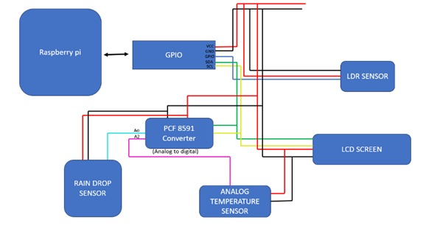

PROTOTYPE
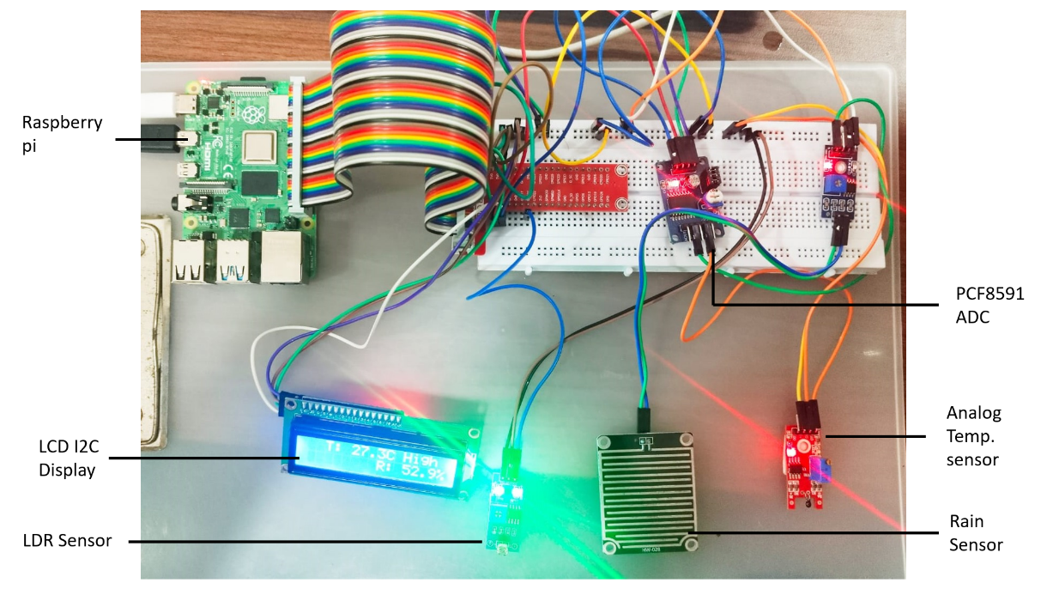

RESULT
The project successfully implemented a real-time weather monitoring system using a Raspberry Pi, integrated sensors, and machine learning for temperature prediction.
- Live Data Display on LCD:
The system successfully collected real-time data from sensors measuring temperature, light intensity, and rainfall.
This live data was displayed on an LCD screen attached to the Raspberry Pi, providing immediate visual feedback of the current environmental conditions.
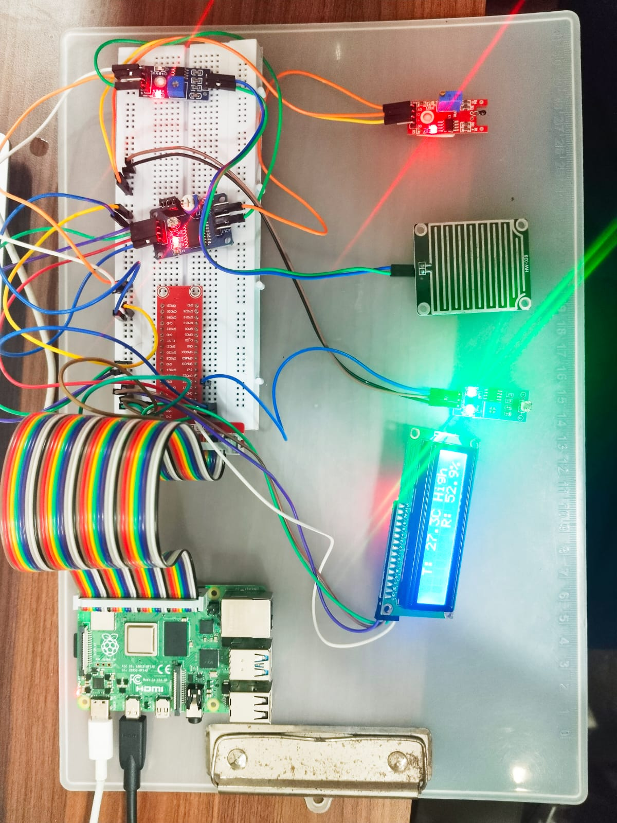

- Data Recording for Future Analysis:
The data from the sensors was systematically recorded in a csv file. This provided a structured and reliable storage solution for storing historical weather data, which would later be used for training machine learning models.
- Machine Learning Model for Temperature Prediction:
The historical temperature data collected over time was used to train a RandomForestRegressor model. The model was able to learn from past temperature trends and predict future temperature changes.
Using this trained model, the system was able to accurately predict future temperatures for the next few hours or days.

- Future Temperature Predictions:
The trained model successfully predicted future temperature trends based on historical data, showing an improvement in forecasting accuracy as more data was recorded and used for model training.
The predictions provided valuable insights into upcoming temperature changes, which could be used for a variety of applications, such as planning for weather-dependent activities or energy management.

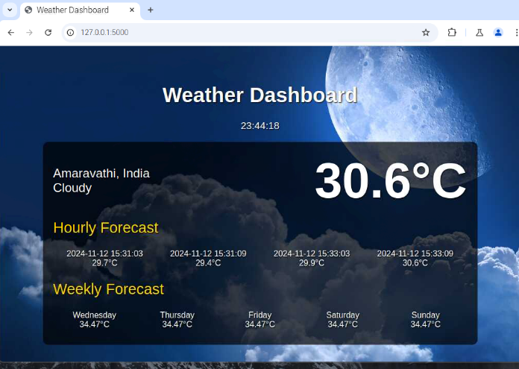

5. Scalable and Expandable System:
The system was designed to be scalable. Additional sensors for measuring more weather parameters (e.g., humidity, wind speed) could be easily integrated.
The machine learning model could be retrained as more data is collected, further improving the accuracy of future temperature predictions

CONCLUSION
By training a machine learning model on this historical data, the system was able to predict future temperature trends accurately. This solution provides a powerful and affordable way to monitor and forecast weather conditions in real-time, with the potential for expansion to include additional environmental factors and more advanced prediction techniques in the future.
Future Scope
- Expanded Sensor Array
Incorporating additional sensors, such as humidity and air pressure sensors, could provide a more comprehensive weather profile and improve prediction accuracy.
- Integration with Cloud Services
Storing and processing data in the cloud would allow for remote monitoring and access from any location, enhancing scalability.
- Advanced Machine Learning Models
Using deep learning models, such as LSTM networks, could improve the accuracy of long-term temperature and weather forecasts.
- Real-Time Notification System
Implementing alerts (SMS or email) could provide users with real-time warnings about sudden changes in weather conditions, making the system proactive in adverse weather scenarios.
- Mobile Application Integration
Creating a mobile app could make the data more accessible and enhance user interaction with real-time updates on the go.

REFERENCES-
- Gupta, A., & Shrivastava, G. (2020). IoT-Based Weather Monitoring System Using Raspberry Pi. International Journal of Advanced Research in Computer and Communication Engineering, 9(6), 25–29.
- Ahmed, M., & Khan, S. (2019). Design and Implementation of a Raspberry Pi-Based Weather Monitoring System. International Journal of Engineering Research and Technology (IJERT), 8(3), 15–19.
- Nithya, M., & Bhargavi, P. (2018). IoT Enabled Weather Monitoring Using Raspberry Pi. Journal of Emerging Technologies and Innovative Research, 5(8), 63–68.
- Reddy, B. T., & Das, R. S. (2019). Real-Time Weather Monitoring System Using Raspberry Pi. Proceedings of the 2019 IEEE International Conference on Electronics and Communication Systems (ICECS), 204–207. IEEE.
- Sundaram, S., & Viswanathan, G. (2021). Weather Monitoring and Forecasting Using IoT with Raspberry Pi. International Journal of Computer Applications, 183(37), 25–28.
- Dash, P., & Tripathy, A. (2020). Implementation of Real-Time Weather Monitoring System Using Raspberry Pi and IoT. Journal of IoT and Information Processing, 4(2), 44–51.
- Raspberry Pi Foundation. (n.d.). Build a Weather Station with a Web Dashboard. Retrieved from https://www.raspberrypi.com
- The Engineering Projects. (2024). Build an IoT-Based Weather Station in Raspberry Pi 4. Retrieved from https://www.theengineeringprojects.com
- Circuit Digest. (n.d.). Raspberry Pi Weather Station: Monitoring Humidity, Temperature, and Pressure. Retrieved from https://circuitdigest.com

